
CITY OF OAKHAVEN, LOUISIANA
Office of Emergency Preparedness · Department of Purchasing
REQUEST FOR PROPOSALS
Architectural & Engineering Design Services
Oakhaven Public Safety Campus
RFP Number | OEP-2026-004
Issued | May 18, 2026
Proposals Due | June 19, 2026, by 2:00 PM Central Time
Submit To | Karen Whitfield, Director of Emergency Preparedness, City of Oakhaven — City Hall, 100 Municipal Plaza, Oakhaven, LA 70634
Project | Oakhaven Public Safety Campus
Delivery Method | Design-Bid-Build (Owner/Architect Agreement: AIA Document B101-2017, Standard Form of Agreement Between Owner and Architect (as modified))
Fictional training exemplar (GRACE PM Academy). Names, figures, and entities are illustrative.

1. Introduction & Invitation
The City of Oakhaven ("the City" or "Owner"), acting through its Office of Emergency Preparedness, invites qualified architectural and engineering firms to submit proposals for full design services for the new Oakhaven Public Safety Campus. The selected firm will serve as the Architect of Record and lead a multidisciplinary team through all phases of design, permitting, bidding, and construction administration.
The City intends to award a single Owner/Architect Agreement based on AIA Document B101-2017, Standard Form of Agreement Between Owner and Architect (as modified). The successful respondent will be expected to deliver a fully coordinated, code-compliant, essential-facility design that consolidates the City's emergency communications, emergency operations, and public-safety administration functions under one hardened roof.

1.1 Project Background
Oakhaven's 911 dispatch operations, emergency operations center, and police and fire administrative offices are presently distributed across three aging leased buildings. None meets current essential-facility standards for storm survivability, redundant power, or secure operations. Following a 2025 needs assessment and voter-approved bond authorization, the City is proceeding with a purpose-built consolidated campus on a City-owned parcel at 1400 Civic Center Drive.

1.2 Project Summary
Parameter | Description
Facility Type | Consolidated Public Safety Facility (911 Emergency Communications / Dispatch, Emergency Operations Center, Police & Fire Administration)
Approx. Gross Area | 55,000 GSF
Stories | Two to three stories
Design Standard | Risk Category IV - Essential Facility (IBC); designed for continuous operation during a design-level event
Site | 9-acre municipal parcel, 1400 Civic Center Drive, Oakhaven, LA 70634
Estimated Construction Budget | $40,000,000 (approx. $725 / SF)
Delivery Method | Design-Bid-Build

1.3 Program Elements
The facility program includes, at minimum:
- A 24/7 hardened 911 Emergency Communications / Dispatch center with a minimum of 8 dispatch console positions and a training/overflow position array;
- A dual-use Emergency Operations Center (EOC) sized for 40 seated positions with breakout and media briefing space;
- Police and Fire administrative offices, report-writing, and shared conference space;
- Secure evidence and equipment storage, IT/server and radio equipment rooms, and a UPS/battery room;
- Staff support spaces: locker/shower, quiet/rest rooms for shift personnel, break room, and fitness;
- Redundant standby power (generator and fuel), redundant HVAC serving mission-critical spaces, and a hardened building envelope;
- Secure site with controlled staff/emergency access separated from public visitor access, a sally port, and a communications tower.

2. Scope of Services Requested
The Owner seeks complete Basic Services across all design and construction phases. Proposals shall address each of the following:

2.1 Basic Services
- Architectural and interior design;
- Structural engineering;
- Mechanical, electrical, plumbing, and fire-protection (MEP/FP) engineering;
- Acoustical design;
- Technology, security, and low-voltage design coordination (dispatch consoles and radio systems are Owner-Furnished; the Architect shall coordinate infrastructure);
- Coordination with the City's separately-retained Civil Engineer (civil / site design is NOT part of this scope — see 2.3);
- Space programming validation and site planning;
- Code compliance review, life-safety analysis, and permitting support with all Authorities Having Jurisdiction (AHJs);
- Cost estimating at Schematic Design, Design Development, and Construction Documents milestones;
- Bidding / negotiation support; and
- Construction Administration, including submittal review, RFI response, field observation, and closeout.

2.2 Design Phases & Deliverables
Services shall be organized in the following phases, consistent with the AIA B101-2017 standard:
Phase | Key Deliverables
Programming | Validated space program, site utilization diagram, project design criteria.
Schematic Design | Site plan, preliminary floor plans, massing/elevations, code analysis, design narrative, SD cost estimate.
Design Development | Developed plans, sections, and elevations; MEP/structural integration; outline specifications; DD cost estimate.
Construction Documents | Complete, coordinated, permit-ready drawings and specifications; CD cost estimate; permit submission support.
Bidding & Negotiation | Addenda, bid-question responses, bid evaluation and award recommendation.
Construction Administration | Submittal/RFI processing, site observation, pay-application review, punch list, and record documents.

2.3 Owner-Furnished Items
- Civil / site engineering — the City is retaining a Civil Engineer under a separate, direct contract; the selected A/E shall coordinate with that consultant;
- Boundary and topographic survey;
- Geotechnical investigation and report;
- 911 dispatch console furniture and CAD/radio dispatch systems (Owner-Furnished, Contractor-Installed coordination required);
- Program of requirements from the 2025 needs assessment.

3. Submittal Requirements
Proposals shall not exceed 30 pages (excluding required forms) and shall be organized in the following order:
- Cover letter and primary point of contact;
- Firm profile, office location(s), and evidence of Louisiana licensure and professional liability insurance;
- Relevant experience — a minimum of three (3) comparable essential-facility or public-safety projects completed within the last ten (10) years, with references;
- Proposed project team, org chart, and résumés for the Principal-in-Charge, Project Manager, and key discipline leads;
- Project approach and methodology, including quality assurance/quality control (QA/QC) and schedule-control processes;
- Proposed design schedule aligned to the milestones in Section 5;
- Fee proposal — a lump-sum Basic Services fee with a phase-by-phase breakdown.
- Completed and signed City procurement and non-collusion forms.

3.1 Questions
All questions shall be submitted in writing to Thomas Nguyen, Purchasing Agent, City of Oakhaven, no later than June 5, 2026. Responses will be issued by written addendum to all registered respondents. Verbal responses are not binding.

4. Evaluation Criteria
A selection committee will score responsive proposals on a 100-point basis. The City reserves the right to shortlist and interview finalists. Award will be based on best overall value, not lowest fee alone.
Criterion | Points | Weight
Relevant essential-facility / public-safety experience | 30 | 30%
Qualifications of the proposed team (PM & discipline leads) | 25 | 25%
Project approach, QA/QC, and schedule control | 20 | 20%
Fee proposal and overall value | 15 | 15%
Local presence and responsiveness | 10 | 10%
Total | 100 | 100%

5. Procurement & Project Schedule
Milestone | Target Date
RFP issued | May 18, 2026
Deadline for written questions | June 5, 2026
Proposals due | June 19, 2026
Finalist interviews (if held) | week of June 29, 2026
Anticipated selection / notice of award | July 13, 2026
Contract execution / Notice to Proceed | July 27, 2026
Design start (kickoff) | August 10, 2026
Design complete / permit & bid | August 5, 2027
Construction start (target) | September 2027

6. General Conditions
- The City reserves the right to reject any or all proposals, to waive informalities, and to award in the City's best interest.
- Costs of proposal preparation are the sole responsibility of the respondent.
- The selected firm shall carry professional liability insurance of not less than $5,000,000 per claim / $5,000,000 aggregate.
- This RFP does not commit the City to award a contract or to pay any costs incurred in the preparation of a proposal.

Appendix A — Conceptual Site Plan
The following illustrative site plan accompanies this RFP to convey the intended site organization, security zoning, and adjacencies. It is conceptual and is provided for respondent orientation only; it is not a survey and is not for construction. Respondents are expected to validate and develop the site design during the design phases.
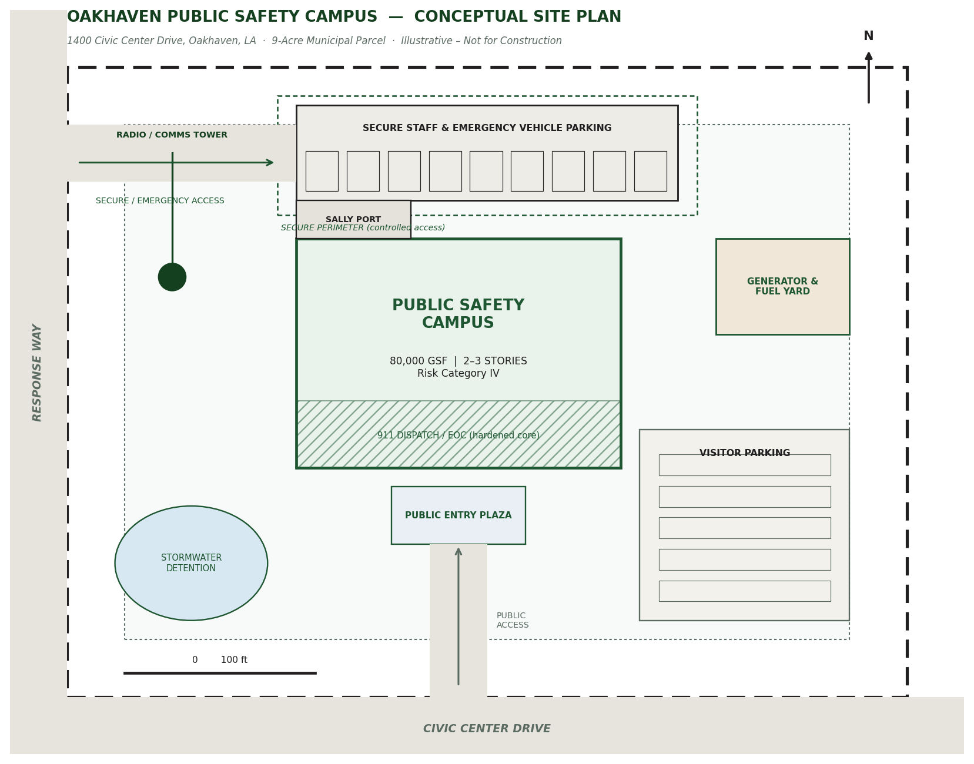
Figure A-1. Oakhaven Public Safety Campus — Conceptual Site Plan (illustrative, not to scale).

