BIM PROJECT EXECUTION PLAN
FOR

Project # 000000

Enter Project Name

DEVELOPED BY


BIM PROJECT EXECUTION PLAN
FOR
Enter Project Name
DEVELOPED BY
Grace Design Studios

Table of Contents
Section A: Checklist 1
Section B: Overview 2
Section C: Project Information 3
1. Project Main Information 3
2. Project Numbers: 3
3. Project Schedule / Phases / Milestones: 3
4. Project Deliverables: 3
Section D: Key Project Contacts 4
Section E: Project Goals / BIM Uses 5
1. Major Goals 5
2. BIM Uses 5
Section F: Protocols & Procedures 6
1. Software 6
Software 6
Software Licenses 6
2. Information Exchange 7
3. Collaboration 7
Autodesk Construction Cloud 7
Section G: Model Organization 8
1. File Naming Structure 8
2. Model File Structure and Linking Method 8
3. Model Element Ownership: 8
4. Sheet Management: 8
5. Measurements & Coordination Systems: 9
Measurements 9
6. Project Information Parameters 9
7. Sheet Layout 10
Sizing and Title Blocks 10
Key plans 10
Building Orientation and North Designation 10
8. Worksets 11
9. Copy Monitor Elements 11
Grids 11
Levels 11
10. Design Options 12
11. Phases 12
12. Additional Modeling Guidelines 12
13. Design Visualization (Renderings) 13
Section H: Modeling Procedures 13
1. BIM Level of Development (LOD) 13
2. CAD Standards 13
3. Owner BIM Standards 14
DELETE THIS PAGE IF NOT NEEDED!!! 14
Section J: Quality Control 15
1. Self-Coordination 15
2. Blue Beam Review Sessions 15
Appendix: 16

Section A: Checklist

BIM Execution Plan Checklist

☐ Edit the Project Title and Number
☐ Check for any Owner or AHJ requirements and edit the BIM Execution Plan (BxP) as required to comply. This may include titleblocks, sheet numbering, file naming, software version, etc. If there are no requirements, delete the section.
☐ Edit the Project Information, address, etc.
☐ Verify the project deliverables.
☐ Edit the GRACE DESIGN STUDIOS contacts.
☐ Schedule a BIM Kick-off meeting. Inform the consultants to review and markup the BxP and for them to have the identity of their Team Model Coordinator.
☐ Update the Goals and Uses.
☐ Update the software version. Companies using AutoCAD will need to specify their version.
☐ Verify the file naming scheme.
☐ Verify Linking method.
☐ Verify Coordinate system.
☐ Select title block style and sheet size and give information to consultants. Create AutoCAD TB version if needed.
☐ Verify Building Orientation.
☐ Create Key Plan for distribution.
☐ Verify Grid ownership.
☐ If known, list planned Design Options that affect other disciplines.
☐ List planned Phases.
☐ Inform consultants of any Rendering requirements.
☐ Educate consultants on how sheet management works. Revit consultants manage their sheets. If the sheets are not listed correctly on the index, it is the fault of the consultant. Non-Revit consultants need to provide arch with list, preferably using GRACE DESIGN STUDIOS supplied excel file.
☐ Edit the Model Element Table (MET) to show work scope if applicable. If a project is not using this table, then delete the page from the appendix.
☐ Update the Table of Contents.

Section B: Overview

To successfully implement Building Information Modeling (BIM) on the Enter Project Name project, GRACE DESIGN STUDIOS has developed this detailed BIM Project Execution Plan. The BIM Project Execution Plan defines uses for BIM on the project (e.g., design authoring, design reviews, 3D coordination, and record modeling), along with a detailed process for BIM execution throughout the project lifecycle.

This document should be a reference for all members of the design team. This chart will provide a quick guide to find information on this document.

WHAT | See Section B: Enter Project Name
WHO | See Section C:  - Grace Design Studios and Consulting Partners
WHY | See Section D: Project's BIM Goals
HOW | See Section E: Protocols & Procedures  See Section F: Model Structure  See Section G: Modeling Procedures  See Section H: Quality Control
WHEN | See Section B: Schedule of submissions

Section C: Project Information

Project Main Information
- Project Owner: Enter Client Name
- Project Name: Enter Project Name
- Project Location & Address: Enter Project Address.
- Contract Type / Delivery Method: Choose Delivery Method
- Brief Project Description: Project Description
- Additional Project Requirements: N/A

Project Numbers:

PROJECT INFORMATION | NUMBER
OWNER’S PROJECT NUMBER: | 000000000000
GRACE DESIGN STUDIOS PROJECT NUMBER: | 000000

Project Schedule / Phases / Milestones:

PROJECT PHASE /  MILESTONE | ESTIMATED START DATE | ESTIMATED COMPLETION DATE | PROJECT STAKEHOLDERS INVOLVED
SCHEMATIC DESIGN | ##/##/#### | ##/##/#### | Grace Design Studios and Consulting Partners
DESIGN DEVELOPMENT | ##/##/#### | ##/##/#### | Grace Design Studios and Consulting Partners
CONSTRUCTION DOCUMENTS | ##/##/#### | ##/##/#### | Grace Design Studios and Consulting Partners
CONSTRUCTION ADMIN | ##/##/#### | ##/##/#### | Grace Design Studios and Consulting Partners

Project Deliverables:
Deliverable to the Owner include the following items.

SUBMITTAL ITEM | STAGE | APPROXIMATE DUE DATE | FORMAT | NOTES
Sheets – Progress Drawing | SCHEMATIC DESIGN | ##/##/#### | .pdf | ???
Sheets – Progress Drawing | DESIGN DEVELOPMENT | ##/##/#### | .pdf | ???
Sheets - Permit Drawing | EARLY RELEASE | ##/##/#### | .pdf | ???
Sheets - Permit Drawing | CONSTRUCTION DOCUMENTS | ##/##/#### | .pdf | ???
Sheets - Record Drawing | CONSTRUCTION ADMIN | ##/##/#### | .pdf | ???

Section D: Key Project Contacts
ROLE | ORGANIZATION | NAME | EMAIL | PHONE | TIME ZONE
ARCHITECTURAL
Principal In Charge | Grace Design Studios | - | - | - | -
Project Manager | Grace Design Studios | - | - | - | -
Project Architect | Grace Design Studios | - | - | - | -
BIM Coordinator | Grace Design Studios | - | - | - | -
BIM Manager | Grace Design Studios | - | - | - | -
Interior Designer | Grace Design Studios | - | - | - | -
VDC Manager | Grace Design Studios | - | - | - | -
CONSULTING PARTNERS
STRUCT  Project Manager | - | - | - | - | -
STRUCT  BIM Manager | - | - | - | - | -
MEP  Project Manager | - | - | - | - | -
MEP  BIM Manager | - | - | - | - | -
CIVIL  Project Manager | - | - | - | - | -
LANDSCAPE  Project Manager | - | - | - | - | -
CONTRACTOR
CONTRACTOR  Project Manager | - | - | - | - | -
CONTRACTOR  VDC Manager | - | - | - | - | -

Section E: Project Goals / BIM Uses

Major Goals

PRIORITY | GOAL DESCRIPTION | POTENTIAL BIM USES
(HIGH/ MED/ LOW) | GOAL DESCRIPTION | POTENTIAL BIM USES
[H] | Increase Effectiveness of Design – Increase efficiency of structural system, lighting/electrical system, and mechanical system | Design Authoring, Design Reviews, 3D Coordination, Engineering Analysis
[H] | Interdisciplinary Design Coordination – Effectively implement BIM through open communication and periodical design reviews | Design Authoring, Design Reviews, 3D Coordination
- | - | -
- | - | -
- | - | -

BIM Uses

X | PLAN | X | DESIGN | X | CONSTRUCT | X | OPERATE
 | PROGRAMMING | X | DESIGN AUTHORING |  | SITE UTILIZATION PLANNING |  | BUILDING MAINTENANCE SCHEDULING
 |  | X | DESIGN REVIEWS |  | CONSTRUCTION SYSTEM DESIGN |  | BUILDING SYSTEM ANALYSIS
 |  | X | 3D COORDINATION | X | 3D COORDINATION |  | ASSET MANAGEMENT
 |  | X | STRUCTURAL ANALYSIS |  | DIGITAL FABRICATION |  | SPACE MANAGEMENT / TRACKING
 |  | X | LIGHTING ANALYSIS |  | 3D CONTROL AND PLANNING |  | DISASTER PLANNING
 |  | X | ENERGY ANALYSIS |  | RECORD MODELING |  | RECORD MODELING
 |  | X | MECHANICAL ANALYSIS
 |  |  | OTHER ENG. ANALYSIS
 |  | X | SUSTAINABLE DESIGN
 |  | X | CODE VALIDATION
 |  |  | PHASE PLANNING  (4D MODELING) |  | PHASE PLANNING  (4D MODELING)
 | COST ESTIMATION |  | COST ESTIMATION | X | COST ESTIMATION
 | EXISTING SITE CONDITIONS MODELING |  | EXISTING SITE CONDITIONS MODELING |  | EXISTING CONDITIONS MODELING
 |  |  | ACOUSTICS ANALYSIS |  | 5D MODELING
 | SITE ANALYSIS |  | SITE ANALYSIS |  | SITE ANALYSIS

Section F: Protocols & Procedures

Software

Software
[Update software versions per agreed contract with each party.]
Purpose | Software | Version | Comments
BIM authoring tool for construction documents | Autodesk Revit | 20##  (Latest Build) | All team members in the design team should use the same version and build. No software updates by a team member without the consensus of the whole team.
CAD authoring tool for Civil and Landscape | Civil 3D  AutoCAD | (Latest Build)  (Latest Build)
Coordination & Clash Detection | For BIM Managers:  ACC/BIM 360 Model Coordination | Version is set by Revit.
Collaboration software or Revit | ACC | Version is set by Revit. | Project site provided by GRACE DESIGN STUDIOS.
Collaboration site | ACC Document Management | N/A | Project site provided by GRACE DESIGN STUDIOS.
Markups, and Review Sessions | ACC  Bluebeam Revu | N/A  21 | GRACE DESIGN STUDIOS will provide the Bluebeam session.

Software Licenses
The project utilizes software and platforms that require paid licenses.
  - Grace Design Studios will host the Autodesk Construction Cloud site. No cost for consultants.
  - Each Team will be responsible to provide and manage the licenses for their Design Authoring Software (Revit, AutoCAD, Civil3D, etc.).
  - Each Team using Revit will be responsible to provide and manage the licenses for Revit collaboration on the ACC platform (BIM Collaborate Pro, Collaboration for Civil 3D, etc.)
  - Each Team will be responsible to provide and manage the licenses for the Review software (Bluebeam Revu)
  - No licenses will be provided by the hosting firm, except for Autodesk Build. If Autodesk Build is being used GRACE DESIGN STUDIOS will provide licenses to access Autodesk Build.

The use of shared licenses is NOT ALLOWED per Autodesk’s licensing agreement. Each team member will be required to have their own license tied to a unique email address for that individual, generic email are not allowed (ex. User1@outlook.com). Grace Design Studios will deny access to accounts that we determine are sharing a license between users.

Click Autodesk links below for more information:
Autodesk Terms of Use
Can I have multiple users on one subscription? (FAQ)

Information Exchange

Type | Name / Location | Protection Type | Update Frequency
Model Exchange | ACC | Project Invites with password protection. | - GRACE DESIGN STUDIOS will provide access for team members.  - Revit Models, published weekly by ACC for coordination and review.  - Each discipline is responsible for creating a published set. The publish is set to occur weekly.
File Storage & Submittal | Choose Storage Platform | Password | GRACE DESIGN STUDIOS will provide access for team members.
Review & Comments | Choose Review Platform | Link & Password | GRACE DESIGN STUDIOS will provide access for team members.

Collaboration

Autodesk Construction Cloud
This project will host all project Revit and CAD files in Autodesk Construction Cloud system.

GRACE DESIGN STUDIOS will administer the site for permissions and team member invitations. Admin privileges will not be given to those not employed by GRACE DESIGN STUDIOS.

Each Team Discipline will have full access to their own folder. Each Team will only have View/Download access to other Team folders.

A folder called Plans-PDF is available to place PDFs of progress sets.

All design files should be in the respective discipline folders as follows:

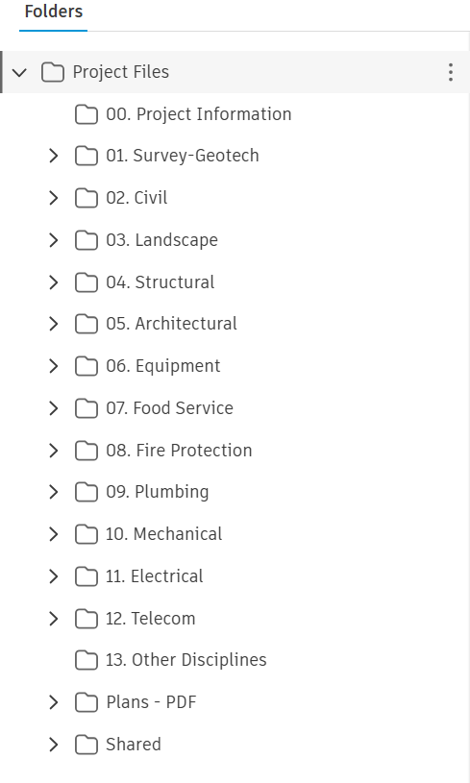

Section G: Model Organization

File Naming Structure

All model files exchanged for coordinated shall have a consistent name in accordance with the following conventions. Model names shall be constant throughout the life of the project to maintain correct file pathing.

Format:
[your company project number]-[building abbreviations/number]-[abbreviation of discipline]_[Revit Version].[File type]

Examples:
Disciplines | Model Names | Type | Description
Architecture and Interior Design | #######_KOC_MOB_r##.rvt | Revit | Modeled building envelope, interior walls, rooms, doors, windows, room finish data, modeled furniture, casework, and equipment
Structure | #######_KOC_MOB-STR_r##.rvt | Revit | Modeled structural systems (columns, beams, bearing walls, floors, roof deck and foundations)
Mechanical, Electrical, Plumbing, Technology  [If MEPT is in one model the extension should be -MEPT] | #######_KOC_MOB-MECH_r##.rvt  #######_KOC_MOB-ELEC_r##.rvt  #######_KOC_MOB-PLUM_r##.rvt  #######_KOC_MOB-TELE_r##.rvt | Revit | Modeled mechanical.  Modeled electrical.  Modeled plumbing system.  Modeled telecom systems
Civil | #######_KOC_MOB-CVL.dwg | Civil3D
Landscape | #######_KOC_MOB-LS.dwg | AutoCAD
Food Service | #######_KOC_MOB-Food.dwg  #######_KOC_MOB-Food_r##.rvt | AutoCAD  If in Revit

Model File Structure and Linking Method
All teams will work from the Autodesk Cloud including teams using AutoCAD. All Revit models will be cloud based workshared models.

All disciplines will use Choose linking style. to link each other’s Revit model.

The Models will be set up based on each team’s discipline. Each discipline shall link to the other disciplines to see the entire project with all disciplines. For example, the Architectural Model will have all other models linked into it to see all the work from the other disciplines.

Model Element Ownership:
The Team shall plan how the models will be created, what will be created, and at what design phases they will be
created and by whom. Use the Model Element Table (MET) to denote this.

Sheet Management:
The Project Coordination Leader will provide all other Team Members with the planned sheet organization and a title
border to utilize. If the Project size is such that it needs to be divided into Areas with match-lines, the Project
Coordination Leader will determine the areas and their identifications. All Team Members will use the same Areas.

The Project Coordination Leader will determine the sheet order and division based on Project needs. All Team Members
will number their sheets in a like manner and ensure that their sheets can be sorted alpha-numerically. If Client
requirements establish a specific title border and/or numbering system, then the Project Coordination Leader will direct
on how to use that.

Measurements & Coordination Systems:

Measurements
The measurement system used is Imperial and its tolerance is set as follows.

Model Type | System | Units | Rounding
Building Model | Imperial | Feet and fractional inches | Nearest 1/256 inch for modeling  Dimensions one-eighth inch
Civil Model | Imperial | Feet and decimal inches | Nearest 0.01 ft

Coordination System
The following conventions are the basis in establishing the primary and all link models.

- The coordinate system that comes from the Civil AutoCAD file will sometimes use the State Plane Coordinates based on the project location.
- Project coordinates will be developed from the Architectural model and/or the Civil AutoCAD file.
- All consultant models shall link to the architectural model using a Choose Coordinate Type.
- If appropriate, an annotation benchmark will be located on the Site/Architectural model. This can be copied and placed on each model for future reference.
- If using Origin to Origin, the project origin will be based on the Architectural model.

Project Information Parameters

All Revit models for buildings should enter information in the Project Information dialog box (Revit Manage > Project Information)
The parameters shown are on the cover sheet and the typical title block. The architectural project manager will provide all submission phase descriptions [7] days prior to the submission date.

Example:

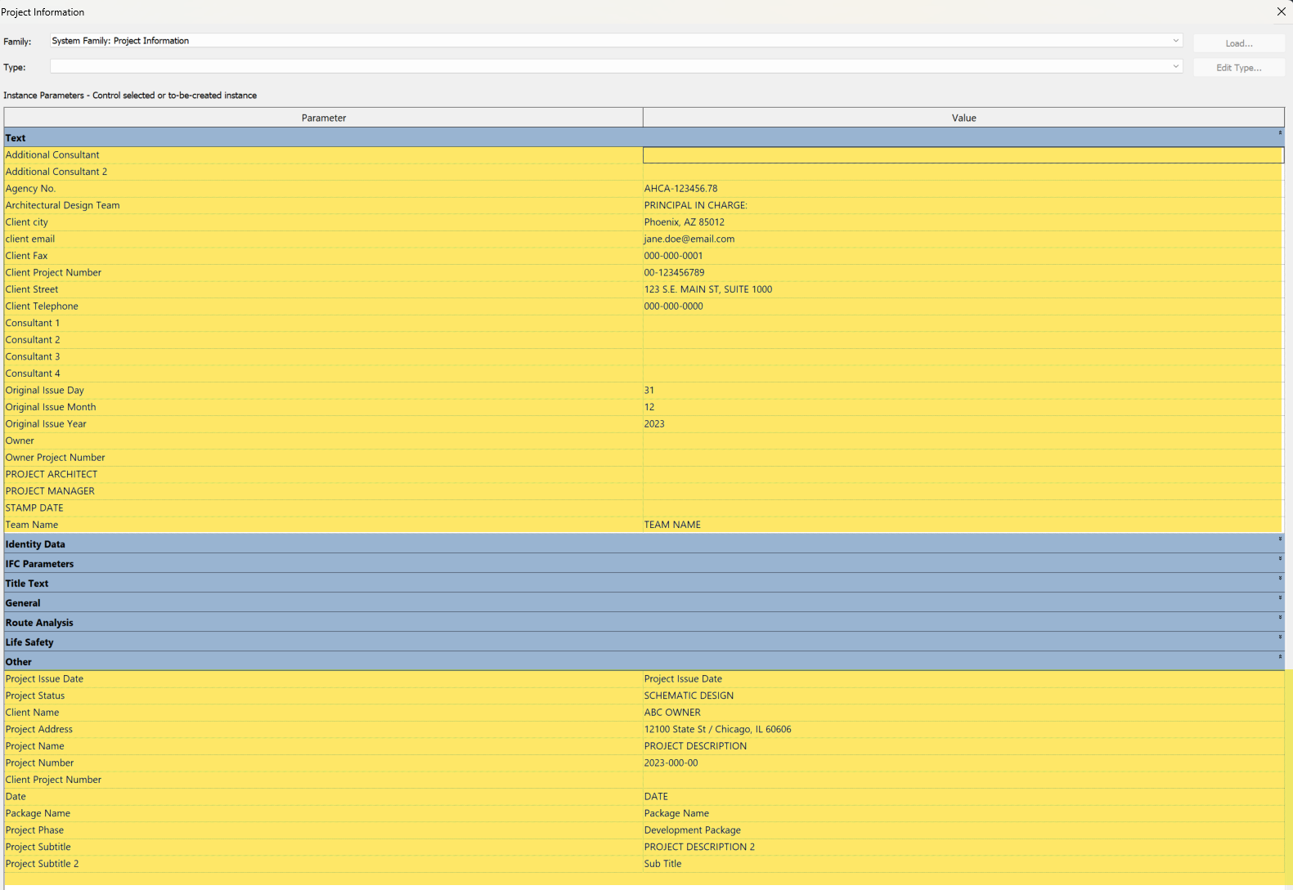

Sheet Layout

Sizing and Title Blocks
Choose sheet size. is the Project Sheet size. The architectural team shall provide a title block family via file exchange system. Revit users will use title block from the Architects Revit model. GRACE DESIGN STUDIOS will provide an AutoCAD title block for AutoCAD users. Consultant’s logo can be located on typical title block family. See examples below.

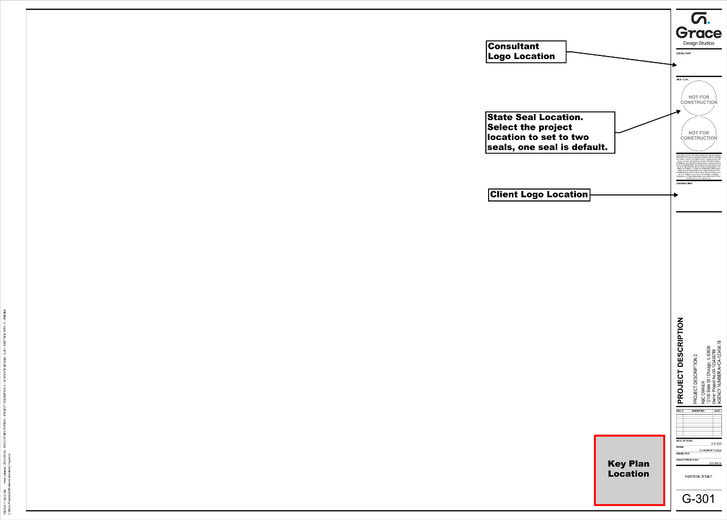

Key plans
All partial plan views of a building should show a key plan. Locate key plan on title block as shown in image above. The key plan family “Projectname_Keyplan.rfa” will be available in the project file exchange system.

Building Orientation and North Designation
The Building Orientation will be defined by the Project Coordination Leader. All Teams will follow this example. If the
orientation needs to be altered; the Project Coordination Leader will reorient the model and give directions to the Team
for how to reorient their models.

All overall plan views should have a project north and a true north symbol correctly indicating the orientation of the building in the view, as per these guidelines.

- Project Site Plan: view orientation should be True North
- Area Site Plan: view orientation should be Project North
- Overall Floor Plan: view orientation should be Project North

Worksets
Worksets are a powerful tool for model coordination, separation of responsibilities, and better computer performance. This project utilizes Worksets. Below is a breakdown of Workset type, its naming convention, and its function.

Type | Name | Description
Revit Native Reference | Shared Levels and Grids | Workset that contains main reference elements like grids and levels.
Building Element | 00-Architectural  01-Furniture  02-Finishes | Building elements (walls, windows, doors, ceilings, floors, roofs, and other model elements.)  All furniture items.  All finish items (carpet, tile, rubber base, corner guards, and other finish elements.)
Link Elements | 03-Structural Revit Link  04-MEP Revit Link  05-Civil CAD Link  06-Other Linked Revit  07-Other Linked CAD | Structural Revit link  MEP Revit link(s)  Civil CAD link  Misc. Revit links  Misc. CAD links

All consultants should place Levels and Grids on the “Shared Levels and Grids” workset.

Do Not Use Worksets for isolation of Revit categories, for personal use, for isolating model elements, etc.

Copy Monitor Elements

Grids
Grid Naming Conventions: Structural and Architectural teams will coordinate grid naming conventions with the BIM Manager. The team will update the BIM Execution Plan to reflect agreement terms. Unless noted otherwise, the Vertical Grids designators will be at the top and numbered left to right. The Horizontal Grids designators will be on the right of the grid and alphabetized from bottom to top. Do not use the letters “O” or “I.” All grids to be located on the “Shared Level & Grids” workset.

Grid Ownership: During SD phase the Architectural team may define a set of grids. Structural consultant shall copy-monitor those grids for their use. Once plans are final and project moves to DD Phase, the Architect and Structural consultant shall determine ownership. If Structural will attain ownership, then the architectural team shall copy monitor from Structural model for the remainder of the project.

Levels
The Architectural model will define all floor levels during schematic design. All consultants copy-monitor levels from architect for initial setup of their models. Consultants will review warnings such as “Linked Model needs Coordination Review” in reference to the linked architectural model. The Coordination Review window will notify the consultants of any changes to the levels in the architect’s model. Consultants should keep the Coordination Review window clear of any messages related to monitored levels from the architectural model. Levels remain in Architects’ control. Visibility of Levels in models are set by view templates. The levels shall be on the “Shared Level & Grids” workset.

Level elevations will be set by GRACE DESIGN STUDIOS and coordinated with the Civil Engineer if needed. Level Names will be set by GRACE DESIGN STUDIOS.

Design Options
Design Options allow the team to share different options with the Owner within the same model. The use of Design Options shall be for alternate design on isolated areas. The project manager/architect will establish the boundary of the design option and will notify the team of the name of the Option Set and along with name and description of the options within the set. Until the Design has approval by the Owner, the various elements within the options will remain within the Option Set. Upon Design Option approval, the selected option will become the Primary option. Documentation will proceed with the primary option. Once the Architect/Project manager deems safe, the team will accept the primary option. After acceptance, delete all other options from the project. Objects will move back to the main model.

Phases
All Revit models have the default phases in Revit templates (Existing and New Construction). Locate all building elements in the appropriate phase. Except for Civil, all new elements will be in the New Construction phase.

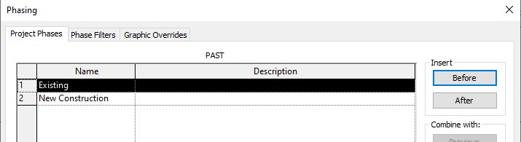

Additional Modeling Guidelines
- Models shall be precise and accurate as required for the LOD, design intent, coordination, and clash detection.

- The model and 2D details should match dimensionally. For example, wall or floor thickness as shown in the detail should match the model. If the detail and model do not match, the model will be considered correct.

- Modeling Elements shall be modeled by the Team Members such that shape, size, and other characteristics (materials, loads, ratings, analysis data, etc.) are all accurate within the specifications of this document and LOD required.

- Model Elements shall be located correctly in the X, Y, and Z axis locations and with the correct work plane or level associated.

- Model Elements shall not be overly complicated. In general, it is preferred and encouraged that elements conform to the LOD established.

- Model Elements shall be constructed using native elements to the Revit platform. Do not use elements that are composed fully or impart with imports such as, but not limited to, DWG, SKP, OBJ, or SAT.

- 2D Model Elements (Detail Components) shall be constructed using Native elements to the Revit Platform. Do not import DWG, SKP, OBJ, or SAT objects.

- Elements for equipment or other items that require clearances for reason of maintenance, accessibility, or other requirements should include an option to graphically show the required clearances. Construct the clearance element such that its visibility can be controlled by other Team Members.

- Avoid the use of Splines in constructing elements. Use Arc instead.

- If Interference Collision is planned to be performed on the model, all Team Members must model accurately both in the size of the entity and its location.

Design Visualization (Renderings)
The model will be used to create renderings. We will need each Team Member to modify the Render Material of some of their elements. This can be done either by Type or using the Paint Tool. As a starting point, the following settings should be used:

- Structural Steel (columns, beams, deck) should have white rendering material applied.
- Mechanical Ductwork should have white rendering material applied.
- While we would prefer to use electrical fixtures from the electrical model, we have found it works better in the renderings if the architect uses lighting in the architectural model so we can control the model, light color and intensity better.
- Should the architect use any item in our model that normally might be in a consultant model (light fixtures, beams, ductwork, etc.), these objects will be placed on a Rendering workset. Any element found on that workset may be ignored by other Team Members for their work

Section H: Modeling Procedures

BIM Level of Development (LOD)

The Level of Development (LOD) defines and illustrates characteristics of model elements of different building systems.

The BIM Forum Level of Development (LOD) Specification (version 2020) is the basis for providing definitions and illustrations of BIM elements of different building systems at various stages of their development and use in the design and construction process for this project.

The team will develop the model elements, which represent the project’s components, to the required geometry and information to provide the required representation within the model and fulfill project requirements.

In practice, the LOD of model elements is based on the project’s goals, model uses and the disciplines or packages’ requirements.

To represent the Project correctly, the team shall model based on the required geometry (LOD) and assigned with required information (LOI) to achieve the required LOD any model elements which represent actual building / structures components.

Project Phase | LOD | Definitions
Programming/Schematic Design | 100 | Model Elements may be graphically represented in the Model with a symbol or other generic representation but do not satisfy the requirements for LOD 200. Information related to the Model Element (i.e., cost per square foot, tonnage of HVAC, etc.) can be derived from other Model Elements.
Design Development | 200 | Model Elements are graphically represented within the Model as a generic system, object, or assembly with approximate quantities, size, shape, location, and orientation. Non-graphic information may also be attached to the Model Element.
Construction Documents | 300 | Model Elements are graphically represented within the Model as a specific system, object, or assembly in terms of quantity, size, shape, location, and orientation. Non-graphic information may be attached to the Model Element.

References:
- BIM Forums LOD document: https://bimforum.org/LOD

CAD Standards
Interface between BIM models and CAD software, when necessary, shall follow the following standards:
- National CAD Standards V6: https://www.nationalcadstandard.org/ncs6/

Owner BIM Standards

DELETE THIS PAGE IF NOT NEEDED!!!

Section J: Quality Control

Self-Coordination
Coordination should begin at each user’s desk. All team members of the design team, OW and consultants, are responsible for doing self-coordination of their work before each submission and or transmission of models. Some tools for self-coordination are provided below.
- Create a 3D Coordination View and name as: [example: BIM 360 COORDINATION VIEW]
- Use the Worksets option of the Worksets Display tool and confirm all objects are on the correct workset.
- Use Interface Check Revit tool.

Blue Beam Review Sessions

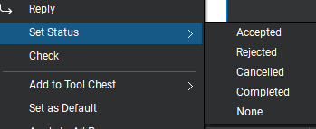
OW may establish Blue Beam coordination sessions at various interval for team review and coordination. Team members working in the project should have access to Blue Beam Revu and their own usernames. OW will provide access to required team members to access marked up comments. When reviewing comments, each reviewer shall set the status of the comment as accepted, rejected, cancelled, or completed. After addressing the comment in the model change Set Status to Completed. If rejecting the comment, ensure you provide a response.

Appendix:

